DASHBOARD
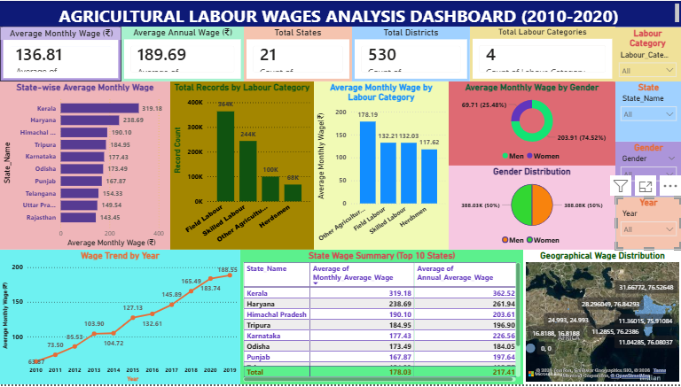

Key Insights from the Dashboard
1. Agricultural Wages Increased Consistently Over Time
- The Wage Trend by Year chart shows a steady increase in average monthly wages from ₹63.87 in 2010 to ₹188.55 in 2019.
- This indicates improving earnings for agricultural labourers over the study period.

2. Kerala Has the Highest Average Agricultural Wage
- The State-wise Average Monthly Wage chart shows Kerala (₹319.18) as the highest-paying state.
- Haryana and Himachal Pradesh also report relatively high wage levels.
- This highlights significant regional wage differences across India.

3. Field Labour Represents the Largest Workforce Segment
- The Total Records by Labour Category chart shows that Field Labour has the highest number of records (around 244K).
- This indicates that field labour is the dominant agricultural labour category in the dataset.

4. Other Agricultural Labour Earns the Highest Average Wage
- The Average Monthly Wage by Labour Category chart shows Other Agricultural Labour (₹178.19) earning the highest average wage.
- Herdsmen receive the lowest average wage among the categories shown.

5. Male Workers Earn Higher Wages Than Female Workers
- The Average Monthly Wage by Gender chart shows:
  - Men: ₹203.91 (74.52%)
  - Women: ₹69.71 (25.48%)
- This suggests a noticeable wage gap between male and female agricultural workers.

6. Gender Representation Is Nearly Equal
- The Gender Distribution chart shows:
  - Men: 50%
  - Women: 50%
- Although participation is balanced, wage levels differ significantly.

7. Significant Wage Variation Exists Across States
- The State Wage Summary Table shows large differences between states.
- Kerala's wages are more than double those of some lower-paying states.
- This indicates unequal earning opportunities across regions.

8. Geographical Patterns Exist in Wage Distribution
- The Geographical Wage Distribution map shows that higher wages are concentrated in specific regions.
- Wage levels vary across locations, suggesting the influence of regional economic and labour market conditions.

